APPENDIX 4. SAMPLE SUPPLEMENTAL AND JOB PREFERENCE QUESTIONS FROM A HEALTH WORKER SURVEY (Computer-based)

Determining the right incentives to attract and retain health workers:
The case of pharmacists in Namibia

PARTICIPANT CONSENT

Thank you very much for your time today. IntraHealth International is working with the Ministry of Health and Social Services and the University of Namibia to conduct a study. IntraHealth is an international health and development organization based in the United States.

We are requesting pharmacists from many parts of Namibia to respond to this survey. The goal of this study is to examine the factors affecting health professionals’ motivations for working in rural areas in Namibia. We would like to ask you to participate in this study. If you agree, you will respond to this survey. We expect this will take approximately 30 minutes.

There are no right or wrong answers. We would just like your honest feedback about your working life. You will be asked questions to obtain basic demographic information. Then you will be asked to review a series of hypothetical job postings and select your preference.

Your responses may provide insights into the best strategies for designing future incentive packages to help attract and retain health workers in rural areas.

Click on the arrows at the bottom of the screen to navigate the survey. To view the survey in full screen mode, please click F11.
Informed Consent
Introduction You are being asked to take part in a study examining preferences for working at district hospitals in Namibia. In order to ensure that you are informed about the study, we are asking you to read this consent form.
Purpose This study is being conducted by the Ministry of Health and Social Services in collaboration with IntraHealth International and the University of Namibia.
This study will gather information mainly on pharmacists' preferences related to job postings in district hospitals. Basic demographic information, such as gender and age, will also be collected.
Your Part in the Study If you agree to participate in the study, you will be asked to complete a survey that takes approximately 20-30 minutes.
If You Decide Not to Participate in the Study Your participation in the study is voluntary. There is no penalty for refusing to take part.
Confidentiality The information you provide will be confidential. We will not put your name on the form on which your responses will be recorded. If we publish the results of the study, your name will not be in it.
Benefits There is no financial compensation or other personal benefits from participating in the study. However, your responses may provide insights into the best strategies for designing future incentive packages to help attract and retain pharmacists at district hospitals.
Risks or Discomfort There are no known risks to you resulting from your participation in the study. If you experience any personal discomfort, you may, as stated above, stop at any time or refuse to answer any questions.
Contact Person for Questions If you have any questions about the study in general, your rights as a participant in this study or any problems with the study you may contact [NAME] at the following telephone number: ________________.
Do you agree to participate in this study?
○ Yes, I agree to participate.
○ No, I do not agree to participate.
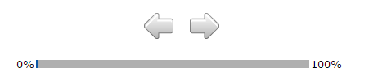

Section A: Demographic and Background Information

1. What is your gender?
□ Male
□ Female

2. How old are you in years? _____

3. What is your nationality?
□ Namibian
□ Angolan
□ American
□ Congolese
□ Cuban
□ Egyptian
□ Nigerian
□ South African
□ Ugandan
□ Zambian
□ Zimbabwean
□ Other (please specify) ___________________

4. What is your current relationship status?
□ Single
□ Married
□ Cohabiting
□ Divorced/separated
□ Widowed

5. How many children do you have? (If none, please enter "0".) ______

6. Are you currently a student or practicing full-time?
□ I am a student.
□ I am practicing as a full-time pharmacist.

(If response to question 6 is “I am a student”:)

7a. In which year of study are you?
□ First
□ Second
□ Third
□ Fourth
□ Other (please specify) ___________________

(If response to question 6 is “I am practicing as a full-time pharmacist”:)

7b. For how many years have you been a practicing pharmacist? ____

8. In which region did you do your attachment? (Choose all that apply.)
□ Caprivi
□ Erongo
□ Hardap
□ Karas
□ Kavango East
□ Kavango West
□ Khomas
□ Kunene
□ Ohangwena
□ Omaheke
□ Omusati
□ Oshana
□ Oshikoto
□ Otjozondjupa
□ I have not yet done my attachment.
□ I did my schooling outside of Namibia.

9. Have you ever worked at a district hospital, including during your attachment?
□ Yes
□ No

10. Have you ever lived in a rural area for more than one year?
□ Yes
□ No

Section B: Job preferences

Imagine that your are thinking about finding another job. You find two postings in government facilities. One of these postings is at a district hospital and the other is at a national tertiary hospital in Windhoek.

Please imagine yourself in this situation and make a decision as to which of the two presented postings you would prefer. For the sake of this survey, please assume that you would receive the full benefits described for both of the postings.

In making your choice, please carefully read the full list of benefits for each posting and do not imagine any additional features of the postings. There will be 12 different scenarios presented.

Please note that while they may look similar at first, they are indeed each very different.

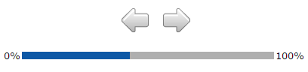

Which of these two job postings do you prefer? Select one by marking the circle under the job you prefer.

District hospital National tertiary hospital
Housing | Housing allowance | Well-maintained government housing provided
Living Conditions | Always good availability and access to amenities (running water, electricity, supermarkets, internet) | Availability and access to basic amenities (running water, electricity)
Monthly Salary | 30% additional salary | 10% additional salary
Children's Education | No good schools close by | Good schools close by
Career Advancement | Eligible for promotion after 1 year | Eligible for promotion after 2 years
Scope of Practice with Available Resources | Narrow scope of practice with limited opportunity to apply skills due to lack of resources (human, supplies, equipment, infrastructure) | Wide scope of practice and opportunity to apply skills due to availability of resources (human, supplies, equipment, infrastructure)
 | ○ | ○

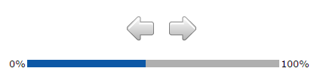

Which of these two job postings do you prefer? Select one by marking the circle under the job you prefer.

District hospital National tertiary hospital
Housing | Housing allowance | No housing allowance
Living Conditions | Always good availability and access to amenities (running water, electricity, supermarkets, internet) | Availability and access to basic amenities (running water, electricity)
Monthly Salary | No additional salary | 20% additional salary
Children's Education | Good schools close by | No good schools close by
Career Advancement | Eligible for promotion after 1 year | Eligible for promotion after 2 years
Scope of Practice with Available Resources | Wide scope of practice and opportunity to apply skills due to availability of resources (human, supplies, equipment, infrastructure) | Narrow scope of practice with limited opportunity to apply skills due to lack of resources (human, supplies, equipment, infrastructure)
 | ○ | ○

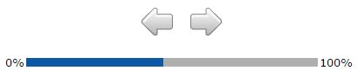

Which of these two job postings do you prefer? Select one by marking the circle under the job you prefer.

District hospital National tertiary hospital
Housing | Housing allowance | No housing allowance
Living Conditions | Always good availability and access to amenities (running water, electricity, supermarkets, internet) | Availability and access to basic amenities (running water, electricity)
Monthly Salary | No additional salary | 20% additional salary
Children's Education | Good schools close by | No good schools close by
Career Advancement | Eligible for promotion after 1 year | Eligible for promotion after 2 years
Scope of Practice with Available Resources | Wide scope of practice and opportunity to apply skills due to availability of resources (human, supplies, equipment, infrastructure) | Narrow scope of practice with limited opportunity to apply skills due to lack of resources (human, supplies, equipment, infrastructure)
 | ○ | ○

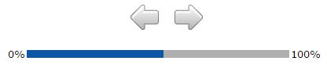

Which of these two job postings do you prefer? Select one by marking the circle under the job you prefer.

District hospital National tertiary hospital
Housing | Well-maintained government housing provided | No housing allowance
Living Conditions | Always good availability and access to amenities (running water, electricity, supermarkets, internet) | Availability and access to basic amenities (running water, electricity)
Monthly Salary | 20% additional salary | 30% additional salary
Children's Education | Good schools close by | No good schools close by
Career Advancement | Eligible for promotion after 2 years | Eligible for promotion after 1 year
Scope of Practice with Available Resources | Narrow scope of practice with limited opportunity to apply skills due to lack of resources (human, supplies, equipment, infrastructure) | Wide scope of practice and opportunity to apply skills due to availability of resources (human, supplies, equipment, infrastructure)
 | ○ | ○

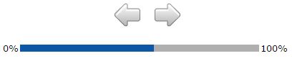

Which of these two job postings do you prefer? Select one by marking the circle under the job you prefer.

District hospital National tertiary hospital
Housing | Housing allowance | No housing allowance
Living Conditions | Always good availability and access to amenities (running water, electricity, supermarkets, internet) | Availability and access to basic amenities (running water, electricity)
Monthly Salary | No additional salary | 10% additional salary
Children's Education | No good schools close by | Good schools close by
Career Advancement | Eligible for promotion after 2 years | Eligible for promotion after 1 year
Scope of Practice with Available Resources | Wide scope of practice and opportunity to apply skills due to availability of resources (human, supplies, equipment, infrastructure) | Narrow scope of practice with limited opportunity to apply skills due to lack of resources (human, supplies, equipment, infrastructure)
 | ○ | ○

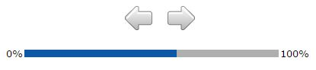

Which of these two job postings do you prefer? Select one by marking the circle under the job you prefer.

District hospital National tertiary hospital
Housing | Housing allowance | Well-maintained government housing provided
Living Conditions | Availability and access to basic amenities (running water, electricity) | Always good availability and access to amenities (running water, electricity, supermarkets, internet)
Monthly Salary | No additional salary | 20% additional salary
Children's Education | No good schools close by | Good schools close by
Career Advancement | Eligible for promotion after 2 years | Eligible for promotion after 1 year
Scope of Practice with Available Resources | Narrow scope of practice with limited opportunity to apply skills due to lack of resources (human, supplies, equipment, infrastructure) | Wide scope of practice and opportunity to apply skills due to availability of resources (human, supplies, equipment, infrastructure)
 | ○ | ○

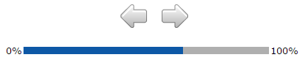

Which of these two job postings do you prefer? Select one by marking the circle under the job you prefer.

District hospital National tertiary hospital
Housing | Well-maintained government housing provided | No housing allowance
Living Conditions | Availability and access to basic amenities (running water, electricity) | Always good availability and access to amenities (running water, electricity, supermarkets, internet)
Monthly Salary | 30% additional salary | 10% additional salary
Children's Education | No good schools close by | Good schools close by
Career Advancement | Eligible for promotion after 1 year | Eligible for promotion after 2 years
Scope of Practice with Available Resources | Narrow scope of practice with limited opportunity to apply skills due to lack of resources (human, supplies, equipment, infrastructure) | Wide scope of practice and opportunity to apply skills due to availability of resources (human, supplies, equipment, infrastructure)
 | ○ | ○

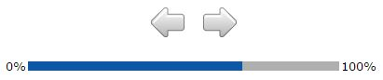

Which of these two job postings do you prefer? Select one by marking the circle under the job you prefer.

District hospital National tertiary hospital
Housing | No housing allowance | Housing allowance
Living Conditions | Availability and access to basic amenities (running water, electricity) | Always good availability and access to amenities (running water, electricity, supermarkets, internet)
Monthly Salary | No additional salary | 10% additional salary
Children's Education | Good schools close by | No good schools close by
Career Advancement | Eligible for promotion after 1 year | Eligible for promotion after 2 years
Scope of Practice with Available Resources | Narrow scope of practice with limited opportunity to apply skills due to lack of resources (human, supplies, equipment, infrastructure) | Wide scope of practice and opportunity to apply skills due to availability of resources (human, supplies, equipment, infrastructure)
 | ○ | ○

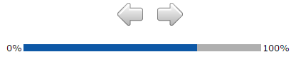

Which of these two job postings do you prefer? Select one by marking the circle under the job you prefer.

District hospital National tertiary hospital
Housing | Well-maintained government housing provided | Housing allowance
Living Conditions | Availability and access to basic amenities (running water, electricity) | Always good availability and access to amenities (running water, electricity, supermarkets, internet)
Monthly Salary | 20% additional salary | 30% additional salary
Children's Education | No good schools close by | Good schools close by
Career Advancement | Eligible for promotion after 1 year | Eligible for promotion after 2 years
Scope of Practice with Available Resources | Wide scope of practice and opportunity to apply skills due to availability of resources (human, supplies, equipment, infrastructure) | Narrow scope of practice with limited opportunity to apply skills due to lack of resources (human, supplies, equipment, infrastructure)
 | ○ | ○

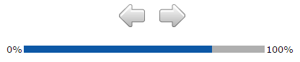

Which of these two job postings do you prefer? Select one by marking the circle under the job you prefer.

District hospital National tertiary hospital
Housing | No housing allowance | Well-maintained government housing provided
Living Conditions | Availability and access to basic amenities (running water, electricity) | Always good availability and access to amenities (running water, electricity, supermarkets, internet)
Monthly Salary | 30% additional salary | 10% additional salary
Children's Education | Good schools close by | No good schools close by
Career Advancement | Eligible for promotion after 2 years | Eligible for promotion after 1 year
Scope of Practice with Available Resources | Wide scope of practice and opportunity to apply skills due to availability of resources (human, supplies, equipment, infrastructure) | Narrow scope of practice with limited opportunity to apply skills due to lack of resources (human, supplies, equipment, infrastructure)
 | ○ | ○

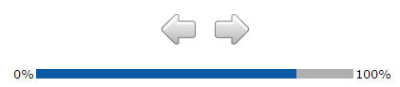

Which of these two job postings do you prefer? Select one by marking the circle under the job you prefer.

District hospital National tertiary hospital
Housing | No housing allowance | Housing allowance
Living Conditions | Always good availability and access to amenities (running water, electricity, supermarkets, internet) | Availability and access to basic amenities (running water, electricity)
Monthly Salary | 20% additional salary | No additional salary
Children's Education | No good schools close by | Good schools close by
Career Advancement | Eligible for promotion after 2 years | Eligible for promotion after 1 year
Scope of Practice with Available Resources | Narrow scope of practice with limited opportunity to apply skills due to lack of resources (human, supplies, equipment, infrastructure) | Wide scope of practice and opportunity to apply skills due to availability of resources (human, supplies, equipment, infrastructure)
 | ○ | ○

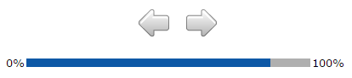

Which of these two job postings do you prefer? Select one by marking the circle under the job you prefer.

District hospital National tertiary hospital
Housing | No housing allowance | Well-maintained government housing provided
Living Conditions | Always good availability and access to amenities (running water, electricity, supermarkets, internet) | Availability and access to basic amenities (running water, electricity)
Monthly Salary | 30% additional salary | 10% additional salary
Children's Education | No good schools close by | Good schools close by
Career Advancement | Eligible for promotion after 1 year | Eligible for promotion after 2 years
Scope of Practice with Available Resources | Wide scope of practice and opportunity to apply skills due to availability of resources (human, supplies, equipment, infrastructure) | Narrow scope of practice with limited opportunity to apply skills due to lack of resources (human, supplies, equipment, infrastructure)
 | ○ | ○

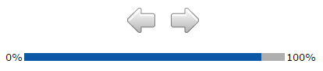

Which of these two job postings do you prefer? Select one by marking the circle under the job you prefer.

District hospital National tertiary hospital
Housing | Housing allowance | Well-maintained government housing provided
Living Conditions | Always good availability and access to amenities (running water, electricity, supermarkets, internet) | Availability and access to basic amenities (running water, electricity)
Monthly Salary | 20% additional salary | No additional salary
Children's Education | Good schools close by | No good schools close by
Career Advancement | Eligible for promotion after 1 year | Eligible for promotion after 2 years
Scope of Practice with Available Resources | Narrow scope of practice with limited opportunity to apply skills due to lack of resources (human, supplies, equipment, infrastructure) | Wide scope of practice and opportunity to apply skills due to availability of resources (human, supplies, equipment, infrastructure)
 | ○ | ○

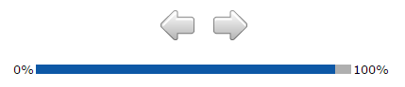

Otwa pa ndula, Dankie, Thank you, Ndangi, Aio

This marks the end of the survey. We thank you for your time.

If you are taking this survey in a computer lab, then please raise your hand to inform the survey administrator that you are finished.

If you are taking this survey via the internet, then you may now close your browser.

